class Item:

def __init__(self, title, author, price, stock=0):

self.title = title

self.author = author

self.price = price

self.stock = stock

def get_details(self):

return f"Title: {self.title}, Author: {self.author}, Price: ${self.price}, Stock: {self.stock}"

def update_details(self, **kwargs):

for key, value in kwargs.items():

setattr(self, key, value)

def apply_discount(self, discount_percentage):

self.price -= (self.price * (discount_percentage / 100))

class Book(Item):

def __init__(self, title, author, price, isbn, genre, num_pages, stock=0):

super().__init__(title, author, price, stock)

self.isbn = isbn

self.genre = genre

self.num_pages = num_pages

class Magazine(Item):

def __init__(self, title, author, price, issue_number, publication_date, editor, stock=0):

super().__init__(title, author, price, stock)

self.issue_number = issue_number

self.publication_date = publication_date

self.editor = editor

class DVD(Item):

def __init__(self, title, author, price, director, duration, genre, stock=0):

super().__init__(title, author, price, stock)

self.director = director

self.duration = duration

self.genre = genre

from datetime import datetime

class Customer:

def __init__(self, name, email, username, password):

self.name = name

self.email = email

self.username = username

self.password = password

self.cart = []

self.order_history = []

def add_to_cart(self, item, quantity=1):

self.cart.append((item, quantity))

def remove_from_cart(self, item):

self.cart = [(i, q) for i, q in self.cart if i != item]

def view_cart(self):

total_price = 0

if not self.cart:

print("Your cart is empty.")

else:

print("Your cart:")

for item, quantity in self.cart:

total_item_price = item.price * quantity

total_price += total_item_price

print(f"{item.title} - Quantity: {quantity}, Price per item: ${item.price}, Total price: ${total_item_price}")

print(f"Total Price for all items: ${total_price}")

def checkout(self):

total_price = sum(item.price * quantity for item, quantity in self.cart)

print(f"Total price for your items: ${total_price}")

confirm = input("Do you want to proceed with the checkout? (yes/no): ")

if confirm.lower() == "yes":

print("Thank you for your purchase!")

self.order_history.append((datetime.now(), self.cart))

self.cart = []

else:

print("Checkout canceled.")

def add_item_to_cart(self, bookstore):

print("Available Items in Inventory:")

bookstore.view_inventory()

item_title = input("Enter the title of the item you want to add to cart: ")

quantity = int(input("Enter the quantity: "))

for item in bookstore.inventory:

if item.title.lower() == item_title.lower():

if item.stock >= quantity:

self.add_to_cart(item, quantity)

item.stock -= quantity

print(f"{quantity} {item.title}(s) added to your cart.")

else:

print("Insufficient stock.")

return

print("Item not found in inventory.")

def remove_item_from_cart(self, title):

for i, (item, quantity) in enumerate(self.cart):

if item.title.lower() == title.lower():

del self.cart[i]

print(f"{item.title} removed from your cart.")

return

print("Item not found in your cart.")

def view_order_history(self):

if not self.order_history:

print("You have no previous orders.")

else:

print("Previous Orders:")

for order_time, order_items in self.order_history:

print(f"Order placed on {order_time}:")

for item, quantity in order_items:

print(f"{item.title} - Quantity: {quantity}")

def calculate_order_total(self):

return sum(item.price * quantity for item, quantity in self.cart)

class Staff:

def __init__(self, name, email, role):

self.name = name

self.email = email

self.role = role

class Bookstore:

def __init__(self):

self.inventory = []

self.customers = []

self.staff = [{"username": "OmarSaber", "password": "omar.saber", "role": "admin"}]

def login_staff(self):

username = input("Enter username: ")

password = input("Enter password: ")

for staff_member in self.staff:

if staff_member["username"] == username and staff_member["password"] == password:

return staff_member

print("Invalid username or password.")

return None

def add_item(self, item, staff):

if staff["role"] == "admin":

self.inventory.append(item)

print(f"{item.title} added to inventory.")

else:

print("You don't have permission to perform this action.")

def remove_item(self, title, staff):

if staff["role"] == "admin":

for item in self.inventory:

if item.title.lower() == title.lower():

self.inventory.remove(item)

print(f"{item.title} removed from inventory.")

break

else:

print("Item not found in inventory.")

else:

print("You don't have permission to perform this action.")

def view_inventory(self, staff=None):

if staff is None or staff["role"] != "admin":

print("Available options for customers:")

print("5. Search Items by Title")

print("6. Search Items by Author")

print("7. Search Items by Genre")

print("8. View Cart")

print("9. Checkout")

else:

print("Inventory:")

for item in self.inventory:

print(item.get_details())

def search_items_by_title(self, title):

matching_items = [item for item in self.inventory if title.lower() in item.title.lower()]

if matching_items:

print("Matching Items:")

for item in matching_items:

print(item.get_details())

else:

print("No items found with that title.")

def search_items_by_author(self, author):

matching_items = [item for item in self.inventory if author.lower() in item.author.lower()]

if matching_items:

print("Matching Items:")

for item in matching_items:

print(item.get_details())

else:

print("No items found by that author.")

def search_items_by_genre(self, genre):

matching_items = [item for item in self.inventory if genre.lower() in item.genre.lower()]

if matching_items:

print("Matching Items:")

for item in matching_items:

print(item.get_details())

else:

print("No items found in that genre.")

def add_customer(self, name, email, username, password):

customer = Customer(name, email, username, password)

self.customers.append(customer)

print(f"Customer {name} added.")

def view_customers(self):

print("Customers:")

for customer in self.customers:

print(customer.name)

def login_customer(self):

username = input("Enter username: ")

password = input("Enter password: ")

for customer in self.customers:

if customer.username == username and customer.password == password:

return customer

print("Invalid username or password.")

return None

bookstore = Bookstore()

while True:

print("\nAre you a staff member? (yes/no)")

is_staff = input().lower()

if is_staff == "yes":

user = bookstore.login_staff()

if user is None:

continue

elif is_staff == "no":

user = None

else:

print("Invalid input.")

continue

if user is not None and user["role"] == "admin":

print("\n1. Add Book")

print("2. Add Magazine")

print("3. Add DVD")

print("4. View Inventory")

print("10. Add Customer")

print("11. View Customers")

choice = input("Enter your choice: ")

if choice == "1" or choice == "2" or choice == "3":

if user is not None and user["role"] == "admin":

if choice == "1":

title = input("Enter book title: ")

author = input("Enter author name: ")

price = float(input("Enter price: "))

isbn = input("Enter ISBN: ")

genre = input("Enter genre: ")

num_pages = int(input("Enter number of pages: "))

stock = int(input("Enter stock: "))

book = Book(title, author, price, isbn, genre, num_pages, stock)

bookstore.add_item(book, user)

elif choice == "2":

title = input("Enter magazine title: ")

author = input("Enter author name: ")

price = float(input("Enter price: "))

issue_number = int(input("Enter issue number: "))

publication_date = input("Enter publication date: ")

editor = input("Enter editor: ")

stock = int(input("Enter stock: "))

magazine = Magazine(title, author, price, issue_number, publication_date, editor, stock)

bookstore.add_item(magazine, user)

else:

title = input("Enter DVD title: ")

author = input("Enter author name: ")

price = float(input("Enter price: "))

director = input("Enter director: ")

duration = input("Enter duration: ")

genre = input("Enter genre: ")

stock = int(input("Enter stock: "))

dvd = DVD(title, author, price, director, duration, genre, stock)

bookstore.add_item(dvd, user)

else:

print("You don't have permission to perform this action.")

elif choice == "4":

bookstore.view_inventory(user)

elif choice == "10":

name = input("Enter customer name: ")

email = input("Enter customer email: ")

username = input("Enter customer username: ")

password = input("Enter customer password: ")

bookstore.add_customer(name, email, username, password)

elif choice == "11":

bookstore.view_customers()

else:

print("Invalid choice.")

else:

print("\n1. Login as Customer")

choice = input("Enter your choice: ")

if choice == "1":

customer = bookstore.login_customer()

if customer:

while True:

print("\n1. Search Items by Title")

print("2. Search Items by Author")

print("3. Search Items by Genre")

print("4. View Cart")

print("5. Add Item to Cart")

print("6. Checkout")

print("7. Logout")

print("8. View Order History")

print("9. Remove from cart")

customer_choice = input("Enter your choice: ")

if customer_choice == "1":

title = input("Enter the title to search: ")

bookstore.search_items_by_title(title)

elif customer_choice == "2":

author = input("Enter the author to search: ")

bookstore.search_items_by_author(author)

elif customer_choice == "3":

genre = input("Enter the genre to search: ")

bookstore.search_items_by_genre(genre)

elif customer_choice == "4":

customer.view_cart()

elif customer_choice == "5":

customer.add_item_to_cart(bookstore)

elif customer_choice == "6":

customer.checkout()

elif customer_choice == "7":

print("Logging out.")

break

elif customer_choice == "8":

customer.view_order_history()

elif customer_choice == "9":

title_to_remove = input("Enter the title of the item to remove from your cart: ")

customer.remove_item_from_cart(title_to_remove)

else:

print("Invalid choice.")

else:

print("Invalid choice.")

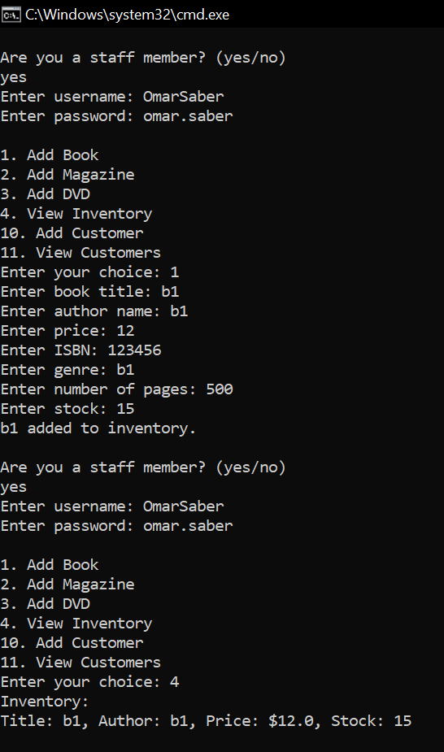

Adding book and viewing inventory

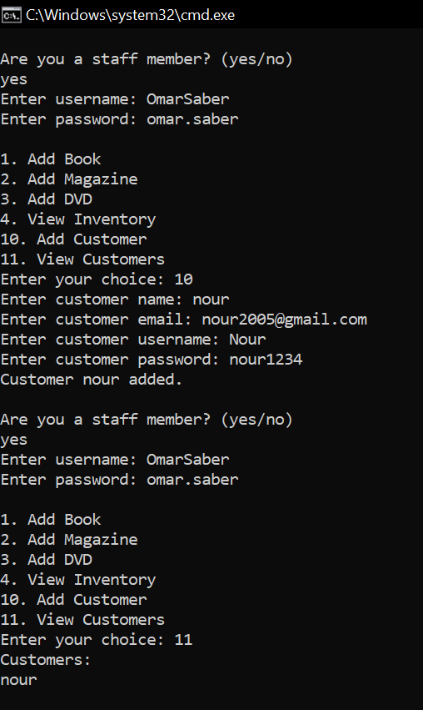adding customer and viewing customers

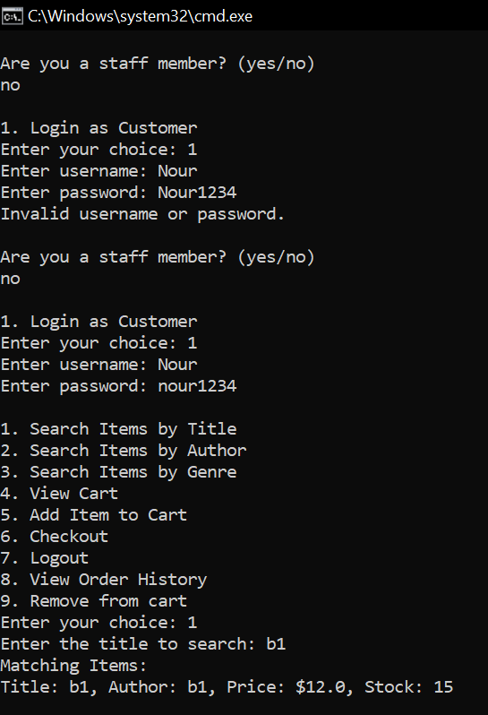logging in as customer ,searching without adding to cart

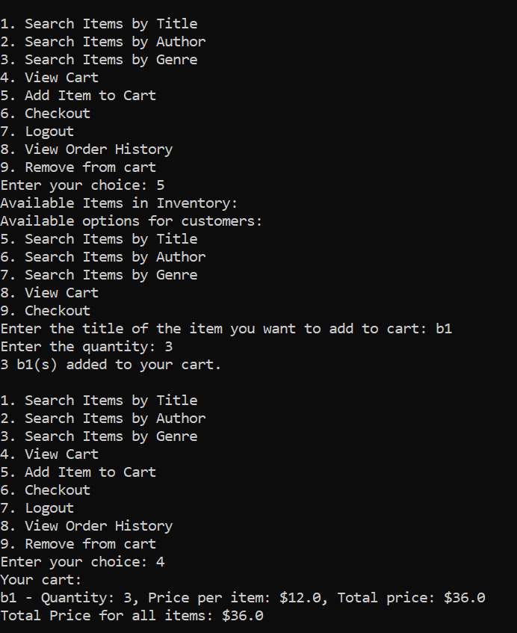adding to cart , viewing cart

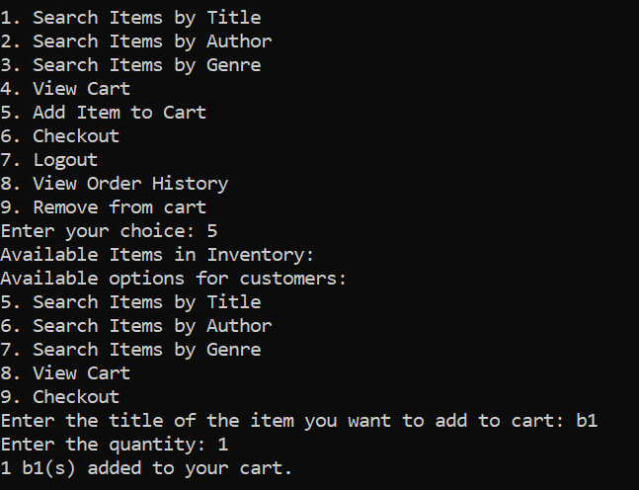adding to cart

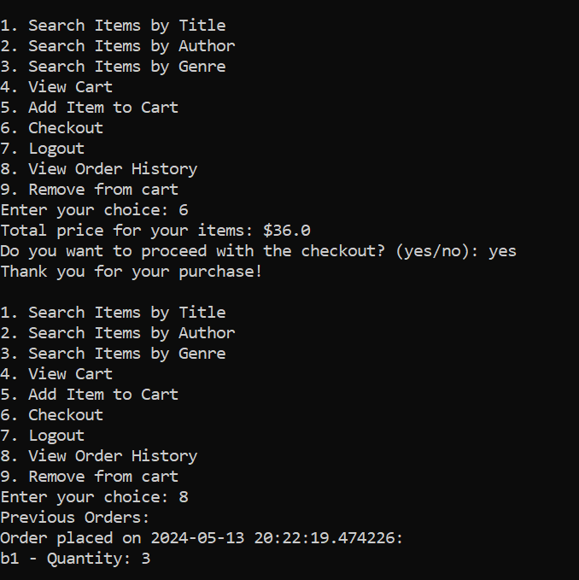checking out , viewing customer history

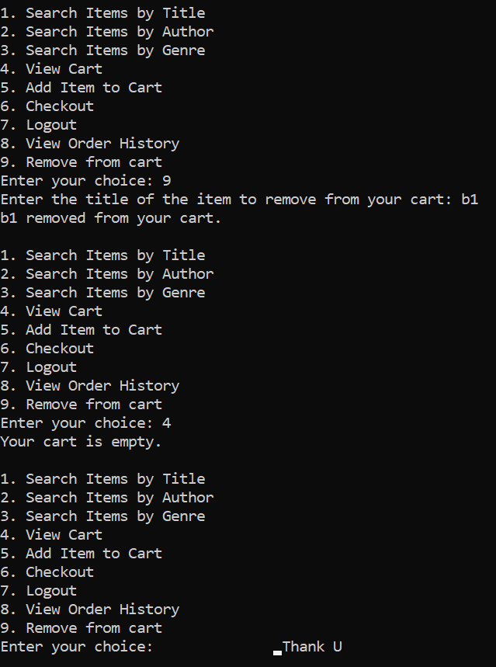

Removing from cart , viewing cart after removing